Social Media toolkit

September Plenary VOTE ON THE AAQD

July/August 2023 social media toolkit

Context
On 12/13 September 2023, the European Parliament is set to vote on the revision of the Ambient Air Quality Directives (AAQD). The 2008 EU Ambient Air Quality Directive is one of the cornerstones of the EU’s clean air policies, setting standards for air quality for the protection of people’s health and the reduction of environmental damage. However, the current air quality standards are insufficient and outdated, i.e. they do not reflect the latest available science. In September 2021 the World Health Organisation (WHO) published their updated recommendations for air quality, based on a thorough scientific review process.

On this critical opportunity for the future of clean air in the EU, let's bring forward the discussion across our social media channels!

visuals
To translate a social media image, please fill in the translation here before 6 August and as soon as possible (as soon as you read this message once back from holidays). The EEB will then send back to you the version in your country language.

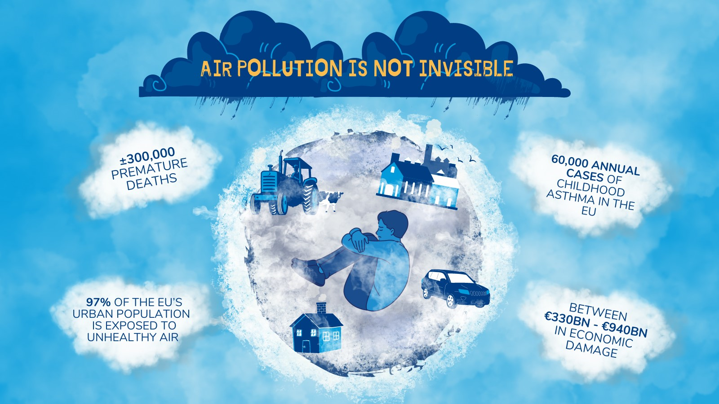

Example of social media image to translate

Social media
Choose one (or all) of the following tweets and translate them into your language. Do not hesitate to tag @Green_Europe and other organisations so that we can engage with your posts, and use #CleanAirEU, #healthyair #Right2HealthyAir to amplify them. Attached are example stock images you could use if you choose not to have a translated version of the social media flyer above.

Tweet | Visual
🤝In September MEPs will decide whether or not they support more ambitious air quality laws that can provide #cleanair for all!  A vote against good air quality laws is a clear and blatant choice to shorten lives, reduce their quality and destroy our nature.  Support the ENVI Committee’s position on AAQD.  #CleanAirEU #healthyair #Right2HealthyAir | Suggested to tag shadow rapporteurs if based in Brussels: @LinsNorbert @KarinKarlsbro @javilopezEU @nicustefanuta @giannagancia @AnnaZalewskaMEP @PetrosKokkalis  Or the MEPs from your national contexts (see below on Targeting MEPs)
🚨Every year, air pollution is responsible for over 60.000 cases of childhood asthma in the EU.  🤝 MEPs have the opportunity to protect our children's lives and to safeguard our nature.  Support the ENVI Committee’s position on AAQD.  #CleanAirEU #healthyair #Right2HealthyAir | Suggested to tag shadow rapporteurs if based in Brussels: @LinsNorbert @KarinKarlsbro @javilopezEU @nicustefanuta @giannagancia @AnnaZalewskaMEP @PetrosKokkalis  Or the MEPs from your national contexts (see above on Targeting MEPs)
🚨In September the European Parliament will vote on Europe’s future air quality laws.  📢We call on all MEPs to do the right thing and vote for an ambitious AAQD that protects our health and nature. Support the ENVI Committee’s position on AAQD.  #CleanAirEU #healthyair #Right2HealthyAir | Suggested to tag shadow rapporteurs if based in Brussels: @LinsNorbert @KarinKarlsbro @javilopezEU @nicustefanuta @giannagancia @AnnaZalewskaMEP @PetrosKokkalis  Or the MEPs from your national contexts (see above on Targeting MEPs)

LinkedIn | Visual
🚨Every year 300.000 premature deaths are caused by air pollution!

🤝In September MEPs will decide whether or not they support more ambitious air quality laws that can provide #cleanair for all!

A vote against good air quality laws is a clear and blatant choice to shorten lives, reduce their quality and destroy our nature.

#CleanAirEU #healthyair #Right2HealthyAir

Targeting MEPs

We highly recommend using the excel document that was included in the sending of this social media pack named PRIORITY MEPs.
If you can expand your effort and target additional MEPs, you can look at the other excel file included in the email, named ‘full list’.
In addition, on this associated website here, you can sort and filter the MEPs you want to target and then download an excel file which contains all their contact information (including their twitter handles).

