**PRESS RELEASE – 2021/03/22**

**CITY 30 - Let's not compromise on road safety!**

***News of a large margin of tolerance for the respect of the 30 km/h speed limit is discrediting this important policy. A coalition of citizen associations engaged in road safety demands a clear message on City 30 and asks to support it by educational, infrastructural, and enforcement measures: they are key to the effective improvement of the safety of all road users.***

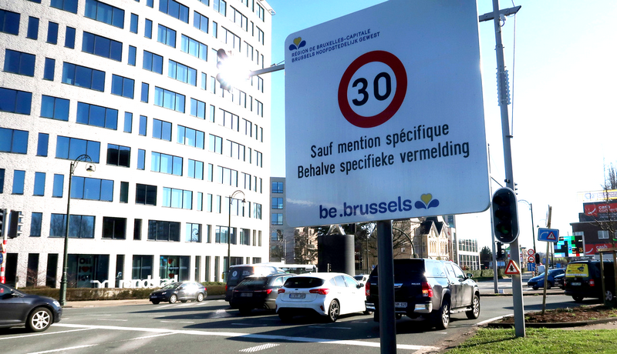

At the beginning of this year, a new law came into force in Brussels: 30 km/h became the general speed limit throughout the Region. This is good news for all road users. According to the European Transport Safety Council, establishing a 30 km/h zone is the most effective way of improving road safety. It reduces the risk of a car colliding with a pedestrian considerably. The consequences of any collision are less severe when a vehicle is travelling at 30 km/h rather than 50 km/h. A pedestrian hit by a car travelling at 50 km/h is 5 times more likely to die than a pedestrian hit by a car travelling at 30 km/h.

Our coalition is grateful that policymakers have decided to implement this rule. However, a few issues still need to be resolved.

According to [press reports](https://www.brusselstimes.com/news/belgium-all-news/160373/speed-cameras-wont-fines-in-brussels-zone-30-until-47-kmh-police-zero-tolerance-policy-van-den-brandt-mobility-committee/), enforcement action will only be taken in respect of vehicles travelling at 47 km/h or more. This lenient approach is apparently a temporary measure, while people get used to the new speed limit. It is unfortunate that this message was spread, because it gives the impression that the speed limit does not need to be respected yet. However, speeding continues to put the lives of people living in Brussels at risk. If we want to improve road safety, the message has to be clear and understood by everyone.

The city-wide 30 km/h speed limit must not be an empty gesture. “*Without enforcement, policy instruments are merely wind instruments*” (Marie Jacuzzi in [Apolitical](https://apolitical.co/en/solution_article/why-only-enforceable-policies-matter?utm_campaign=Weekly%20Briefing%20%E2%80%93%20Platform&utm_medium=email&_hsmi=115118855&_hsenc=p2ANqtz--WNt56SOCdq0O-I-8fqiV37GVkgznLEK594iBEhOohWL9gEoSoB0jqc657EhGmjjAMNvM8UADIG4woO3ybwPkSNU1H2Pf1FAqP0LOcrJfl3ozMWoI&utm_content=115118855&utm_source=hs_email)). Allowing people to drive at 46 km/h without any consequences is unacceptable. It goes against the ethos of a city-wide 30 km/h speed limit.

This rule needs to be backed up by proper enforcement and other measures.

* In terms of enforcement, we want the capacity for law enforcement and judicial follow-up to increase. Some police zones are starting to [confiscate cars of reckless drivers](https://www.bruzz.be/mobiliteit/controles-op-rodeorijden-aan-atomium-drie-wegpiraten-verliezen-rijbewijs-2021-02-21) more often. We want to see this trend generalised across the Region. After imposing a general zone 30, we can reasonably expect a temporary increase in infractions- and tickets and fines. Therefore, more capacity needs to be made available. Once mindsets have adjusted to the City 30, these numbers will fall, and police and judicial force can be used for other matters.
* Other methods can also be used to enforce the law. We ask for increased vigilance during school drop-off and pick-up times. When installed a short distance before mobile speed radars, mobile speed displays allow drivers to be warned that the rule is about to be enforced.
* Education has a key role to play in developing a safety culture. This involves more than just teaching “self-defence” tactics for surviving in traffic. At all ages, people need to be informed and educated about the need for slow and careful driving, its advantages, and current road safety principles (such as “roads are for everybody”). In this way, we can motivate people to take part in creating a new culture of road safety where everyone understands that the road has to be shared.
* Improved road layouts to both slow down traffic and change the physical appearance of streets are important measures to reduce speed and improve safety. While the number of collisions falls by 10% when a 30 km/h speed limit is imposed without any changes to road layout, the number of collisions falls by up to 60% when the road layout is changed (Dirk Lauwers, [Bruzz](https://www.bruzz.be/mobiliteit/de-zone-30-van-achter-het-stuur-goede-zaak-lege-doos-2021-01-13)). Making public space into a more welcoming environment for people is the larger vision in which City 30 is but one measure.

In conclusion, a combination of stricter enforcement, improved road layouts and enhanced education is crucial for improving road safety. Our coalition is committed to road safety of all Brussels road users. We kindly offer the authorities our help to inform the public about the city-wide 30 km/h speed limit and its benefits for safer streets, while we keep monitoring the proper implementation and enforcement of this rule. We hope to see clear communication from now on and appropriate accompanying measures, such as prevention and infrastructure to guarantee more road safety in Brussels.

**Signatories**

BRAL – EUCG – Filter Café Filtré Atelier – Fietsersbond – GRACQ-Les Cyclistes Quotidiens – Heroes for Zero – Johanna.be – Pro Velo – Walk Brussels

**Press contacts**

* Tim Cassiers, BRAL (NL + EN) - 0476 449 223
* Lieselotte Gevens, Fietsersbond (NL + EN) - 0471 49 63 76
* Matteo Manzonetto, Oliver KOZAK, EUCG (EN) 0472 306 074

