**BRAL’s Guidance and Sample Answers to the Questionnaire of the public consultation of the Ambient Air Quality Directives (AAQD) revision**

A revision of the AAQD that strengthens EU air quality standards is an important step to ensure that people’s right to clean air is respected. The new laws must reflect the latest scientific evidence on the health and environmental impacts of air pollution, and support actions to cut pollution at source. EEBs suggested answers in this guide as well as the Response document highlight the demands needed and the reasons behind them.

You can see BRAL’s sample answers below in yellow. You can copy the text (and of course adapt to your own experience, vision and country specific situation). All the guide's open answer suggestions are within the maximum character limits and highlighted in yellow. Do not miss the non-obligatory Specialised questions section (Part 3) which you choose in question 20.

The public consultation is open until the 16th of December 2021. Take part by clicking on [this link](https://ec.europa.eu/info/law/better-regulation/have-your-say/initiatives/12677-Revision-of-EU-Ambient-Air-Quality-legislation/public-consultation_en) and then click on the yellow "respond to questionnaire".

This survey is divided into the following parts:

**Part 1:** About you – questions about yourself and why you are answering this questionnaire.

**Part 2:** General questions section – on your views on air quality issues. This section does not require technical or expert knowledge of the Directives, and anyone can answer.

**Part 3:** Specialised questions section – on your views on air quality measures and their impacts. This section focuses on more technical aspects of the topics/measures considered by the Directives’ revision and may therefore require expert knowledge to answer. This section can be skipped, if preferred.

**Part 4:** Concluding questions & remarks - share your thoughts on topics not covered by the questions and provide further information. This section invites you provide any additional comments or elaborate on

# Part 1: About you No guidance from BRAL needed

# Part 2: General questions section BRAL’s guidance – feel free to change

1. How important is having good air quality to you?

 Very important



 Important

 Of minor importance

 Not important at all

 No opinion

1. How concerned are you about the levels of air pollution to which you are usually exposed?

 Very concerned



 Concerned

 Slightly concerned

 Not concerned at all

 No opinion

1. Are you concerned about the following impacts that air pollution may have in your local area?

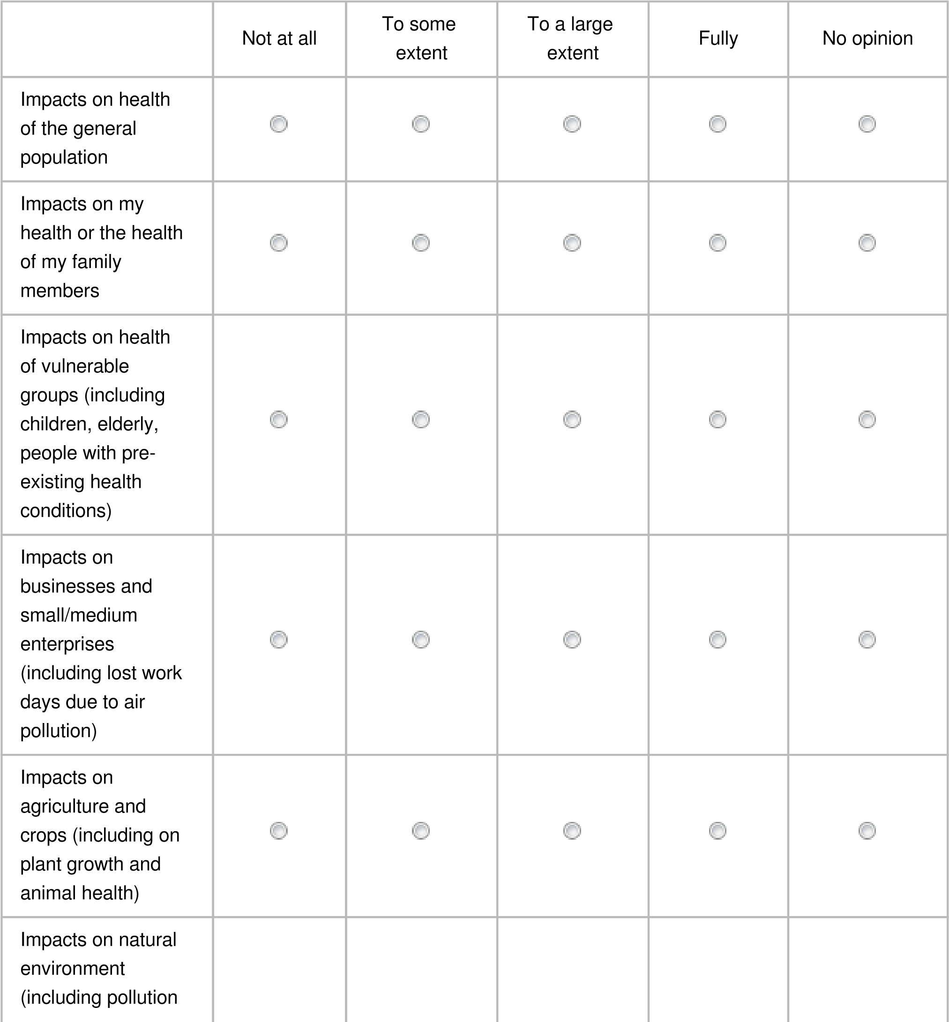



of water bodies, or

reduced

biodiversity)



Impacts on

buildings and

infrastructure

(

including corrosion

or discoloration of

buildings)



1. Which air pollutants are you concerned about?

 Fine particulate matter (PM2,5)



 Particulate matter (PM10)



 Sulphur dioxide (SO2)



 Nitrogen dioxide (NO2)



 Ground-level ozone (O3)



 Carbon monoxide (CO)



 Benzene (C6H6)



 Polycyclic aromatic hydrocarbons (including benzo(a)pyrene)



 Arsenic (As)



 Cadmium (Cd)



 Mercury (Hg)



 Nickel (Ni)



 Lead (Pb)



 Ultra-fine particles



 Black carbon and/or elemental carbon



 Ammonia (NH3)



 Methane (CH4)



 Non-methane volatile organic compounds (i.e. organic compounds capable of producing photochemical oxidants by reaction with nitrogen oxides in the presence of sunlight)



 None

 No opinion  Other

If "other", please specify:

100 character(s) maximum

1. Would you like to see more action to improve air quality? And if so, to what extent?

 Yes, a significant increase in action and ambition to tackle air pollution



 Yes, a moderate increase in action and ambition to tackle air pollution

 Yes, a small increase in action and ambition to tackle air pollution

 No, current action and ambition to tackle air pollution issues is adequate  No opinion

1. At what level should further action be taken?

Please rank the following from 1 – where most action needs to be taken to 5 – where least action needs to be taken

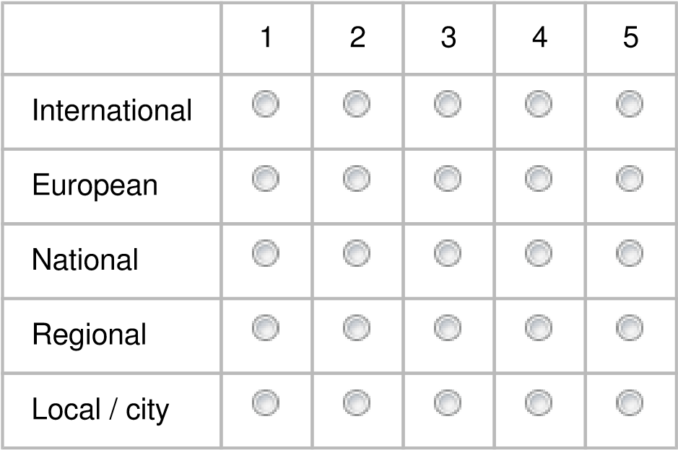



1. To what extent would you be willing to change your own way of living to contribute to improving air quality in your country / region / city? No guidance from BRAL here ☺

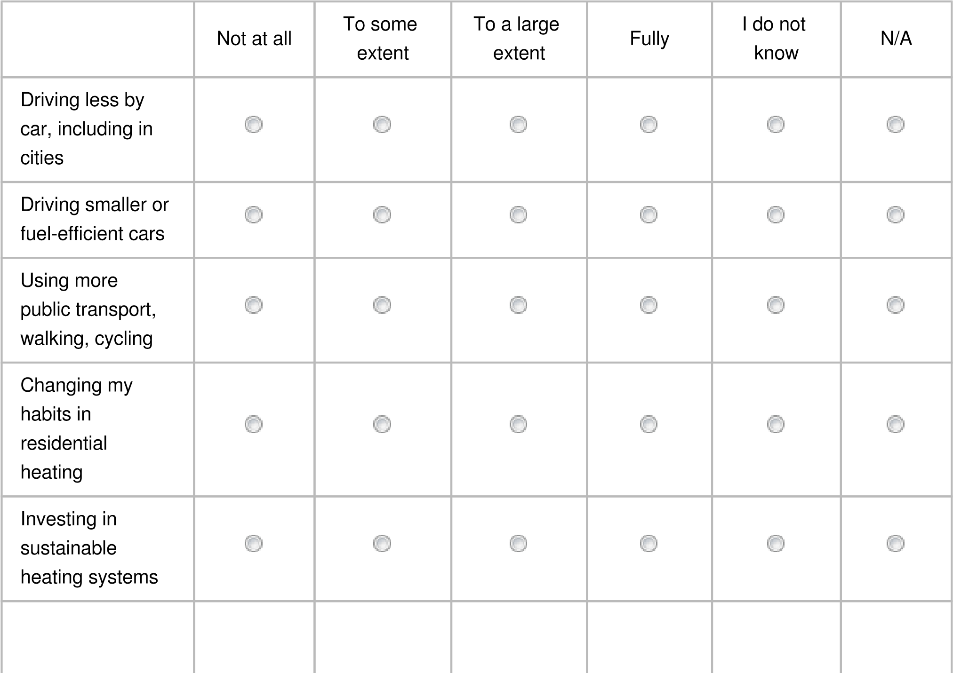

Improving the

energy efficiency

of my home



Making

conscious

consumption

choices to

reduce emissions



Other



If "other", please specify:

100 character(s) maximum

Policy area 1: Closer alignment of the EU air quality standards with scientific knowledge including the latest recommendations of the World Health Organization (WHO).

The Ambient Air Quality Directives set air quality standards for 13 air pollutants. For several air pollutants, these standards are not as stringent as recommended by the World Health Organization via their ‘Air Quality Guidelines’ (which themselves have recently been updated), in particular for the most harmful fine particulate matter (PM2.5). This revision of EU rules will consider and assess different policy options and scenarios to more closely align EU air quality standards with the latest scientific evidence.

1. Do you think that [EU air quality standards](https://ec.europa.eu/environment/air/quality/standards.htm) should be made more stringent to bring them in line with the updated World Health Organization Air Quality Guidelines and latest scientific evidence?

 Yes – EU air quality standards should be made more stringent, fully aligned with the latest WHO recommendations



 Partly – EU air quality standards should be made more stringent, but only

partially aligned with the latest WHO recommendations

 No – current air quality standards are sufficient  No opinion

1. Where (at which locations) should EU air quality standards apply?

 Everywhere, including at locations to which members of the public do not have



access, including industrial installations or motorways

 At all locations where there is fixed habitation or there are commercial facilities, as well as at all locations to which members of the public have

access (including, for example, roads and sidewalks)

At all locations where there is fixed habitation or there are commercial facilities  Only at locations that are representative of the exposure to air pollutants of the general population

 No opinion

1. How quickly should any revised EU air quality standards be achieved?

 As soon as possible

 By 2025 at the latest

 By 2030 at the latest



 By 2040 at the latest

 By 2050 at the latest  No opinion

1. Do you have any other comments regarding the consideration to amend the EU’s air quality standards (this could capture existing achievement of or options to amend the standards, and the feasibility or impacts of such options)?

800 character(s) maximum

The revision must include full alignment with the revised WHO air quality guidelines for protection of health by 2030. Air quality standards in the form of binding limit values have been and will continue to be a key driver for reducing air pollution concentrations.

The revision should also broaden the scope of standards, monitoring and modelling of real time air pollution, including other harmful pollutants, extended alert system for pollution peaks in order to provide tailered alerts to vulnerable groups as well as with regard to certain locations.

Member states and regional authorities should be encouraged to go further to reduce air pollution to the minimum, in line with the Zero Pollution ambition.

Policy area 2: improving the current air quality legislative framework (including aspects such as penalties and public information).

There have been substantial delays in taking appropriate and effective measures to meet all EU air quality standards throughout Member States. Improvements to the legislative framework, including related to access to justice in case of persistent exceedance, as well as to public information, may facilitate further air quality action. This revision of EU rules will consider and assess different policy options for amended provisions on sanctions and penalties to be established in national systems for non-fulfilment of relevant obligations deriving from the Directives. It will also consider options for a stronger harmonisation of public information.

1. Do you believe that the current provisions on penalties in the Ambient Air Quality Directives are sufficient for Member States to comply with EU air quality standards?

 Yes

 Partly

 No



 No opinion

1. Do you believe that the Ambient Air Quality Directives should facilitate access to justice, including compensation for health damages due to air pollution (suffered by groups and/or individuals)?

 Yes – both stronger facilitation of access to justice in general, as well as of compensation for health damages due to air pollution in particular



 Partly – stronger facilitation of access to justice related to air pollution  Partly – compensation for health damages due to air pollution

No



 No opinion

1. How well informed do you feel about air quality in your country / region / city?

 Very well informed

 Well informed

 Somewhat informed

 Little informed

 Not informed at all

 No opinion

1. Which of the following types of information would you want to have easier access to? (Multiple answers possible)

 (Real-time) air quality data / Up-to-date average concentrations



 Annual reports specifically targeted to the general public



 Air pollution forecasts



 Air quality plans and measures the authorities are taking to improve air quality



 Air quality monitoring networks (e.g. location of monitoring stations, pollutants monitored, etc.)



 Information on whether air quality standards are respected



 Air quality benchmarks that allow comparison with other cities/regions



 Access to downloadable historical data sets



 Information on specific precautions and preventative actions



 General information on short term & long term health risks of air pollution



 Alert/ targeted messaging during high pollution events



 Information on citizens’ rights and possible actions if air quality standards are not respected





Other

If "other", please specify:

100 character(s) maximum

16. Are there any other elements related to the legislative framework of the Ambient Air Quality Directives (i.e. around defining the types of air quality standards and actions exceedances trigger, governance and enforcement of actions at MS level, and around information provided to the public) that you would consider effective in facilitating the achievement of its objectives?

800 character(s) maximum

Binding limit values are key for reducing air pollution and improving air quality. Other standards forms, should only be complements to binding limit values.

The AAQD should also put forward a more stringent framework for air quality action plans, setting out clear requirements in terms of demonstration of their effectiveness (calculating the impact of the different measures), and of providing a well defined timeline and pathway towards achieving the limit values.

The AAQD should include guidance on citizens science measurements & integrating and communicating official & citizen science results.

Policy area 3: strengthening of air quality monitoring, modelling and plans.

The Ambient Air Quality Directives have guided the establishment of a robust system for air quality assessment and have framed competent authorities’ action to achieve cleaner air via air quality plans (i.e. the action taken when and where exceedances occur). However, the criteria on air quality monitoring and modelling could be refined to increase the comparability of air quality data. This revision of EU rules will explore solutions to improve, simplify and increase precision and coherence of requirements with regard to air quality monitoring and modelling, and options to facilitate further the effectiveness of air quality plans.

17. Do you see a need to strengthen further the assessment of air quality?

(Multiple answers possible)

 Yes, we need additional monitoring everywhere, whether high pollution or low pollution levels



 Yes, we need additional monitoring where pollution may be a concern

 Yes, we need additional monitoring of background concentrations (i.e. average pollution levels)

 Yes, we need additional monitoring at locations with pollution peaks due to industrial emissions

 Yes, we need additional monitoring at locations with pollution peaks due to traffic emissions



 Yes, we need to ensure detailed modelling of air quality across the EU



 Yes, we need to ensure detailed modelling of air quality at locations with pollution peaks (e.g. due to traffic or industry)



Yes, we need to ensure detailed modelling and forecasting of air pollution episodes



 No, we have sufficient data on air quality

 No opinion

18. Do you see a need to improve air quality plans developed by local authorities to address exceedances of EU air quality standards? (Multiple answers possible)

 Yes, air quality plans need to be clearer on the specific sources and origin of air pollution



 Yes, air quality plans need to explain the health consequences of air pollution



 Yes, air quality plans need to assign responsibilities (i.e. who needs to act)



 Yes, air quality plans need to quantify the costs and benefits of action



 Yes, air quality plans need to spell out how each measure contributes to solving pollution problems



 Yes, air quality plans need to estimate by when action would have resolved the pollution problem



 Yes, air quality plans need to be followed-up by a regular assessment of their implementation



 No need to change air quality plans

 No need to change air quality plans, but they need to be better implemented  No opinion

19. Do you have any comments regarding the improvements of monitoring, modelling and the content of air quality plans (e.g. existing effectiveness, options to improve these elements, and the feasibility or impacts of such options)?

800 character(s) maximum

The AAQD should also put forward a more stringent framework for air quality action plans, setting out clear requirements in terms of demonstration of their effectiveness (calculating the impact of the different measures), of providing a well defined timeline and pathway towards achieving the limit values, of public participation, and of assessment of intermediate goals.

Clear sanctions should be set when any type of standard is exceeded, including exposure reduction targets. The revision should also broaden the scope of standards, monitoring and modelling of real time air pollution, including other harmful pollutants (especially black carbon and ultrafine particles). It should provide clear indications on the site location, and allow for modelling and sampling data to be included in assessment of air quality infringements.

# Part 3: Specialised questions section

*20. Please indicate if you would like to answer this more specialised questions section on your views on air quality measures and their impacts. This section focuses on more technical aspects of the topics/measures considered by the Directives’ revision

Yes, I would like to reply to this section with more specialised questions (to Part 3)



 No, I would like to skip ahead to the final section of this questionnaire (to Part 4)

1. How important are the following options for policy area 1* to improve the effectiveness of the Ambient Air Quality Directives?

*Closer alignment of the EU air quality standards with scientific knowledge including the latest recommendations of the World Health Organization (WHO).

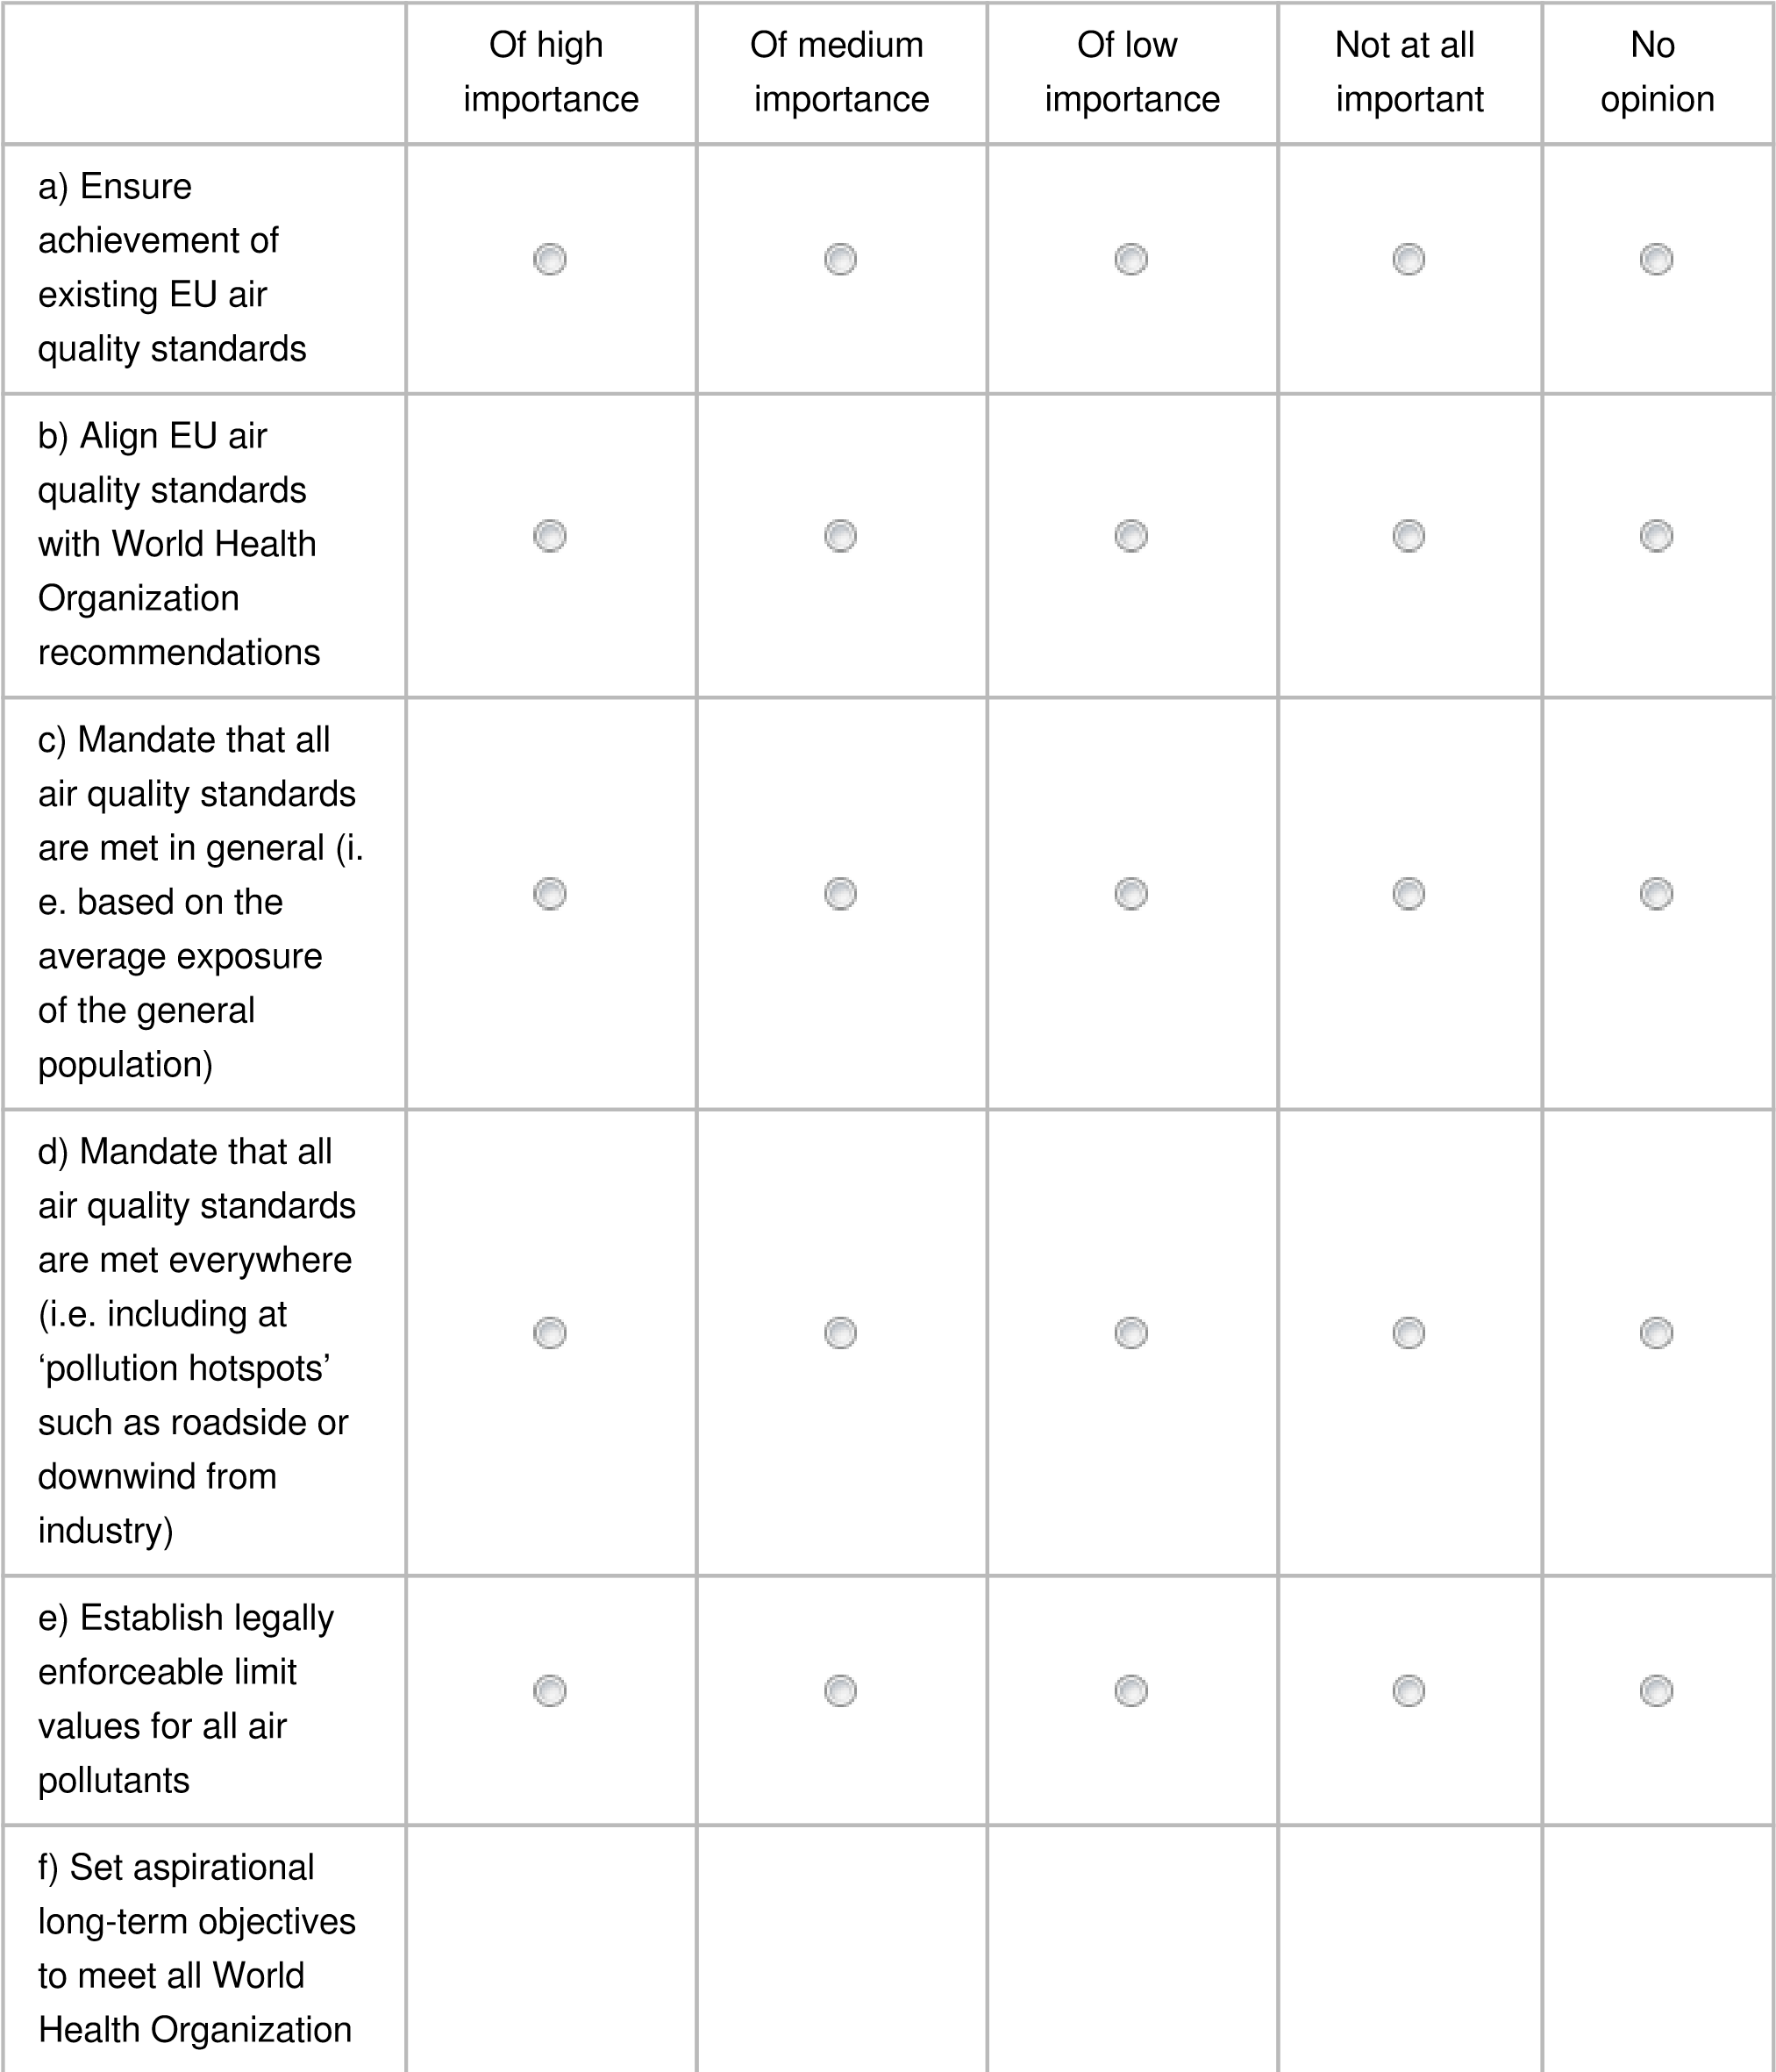



(

WHO)

recommendations (i.

e. as per updated

WHO Air Quality

Guidelines)



EU standards must follow best available scientific knowledge and advice

Already long overdue. A must for minimum protection of health & environment

See fitness check conclusion: “limit values have been more effective than any other type of air quality standards”

This is key to protect vulnerable groups including children; elderly; people with chronic respiratory, cardiovascular diseases, diabetes; people living in poverty

Useful but average exposure only an addition to binding limit values everywhere.

Short term urgent action is required to protect health.

100

character(s) maximum

100

character(s) maximum

a) Ensure achievement of existing EU air quality standards

b) Align EU air quality standards with World Health Organization recommendations EU standards must follow best available scientific knowledge and advice

c) Mandate that all air quality standards are met in general (i.e. based on the average

exposure of the general population)

d) Mandate that all air quality standards are met everywhere (i.e. including at ‘pollution

hotspots’ such as roadside or downwind from industry)

e) Establish legally enforceable limit values for all air pollutants

f) Set aspirational long-term objectives to meet all World Health Organization (WHO)

recommendations (i.e. as per updated WHO Air Quality Guidelines)

Other

1. How important are the following options for policy area 2* to improve the effectiveness of the Ambient Air Quality Directives?

* Improving the current air quality legislative framework (including aspects such as penalties and public information).

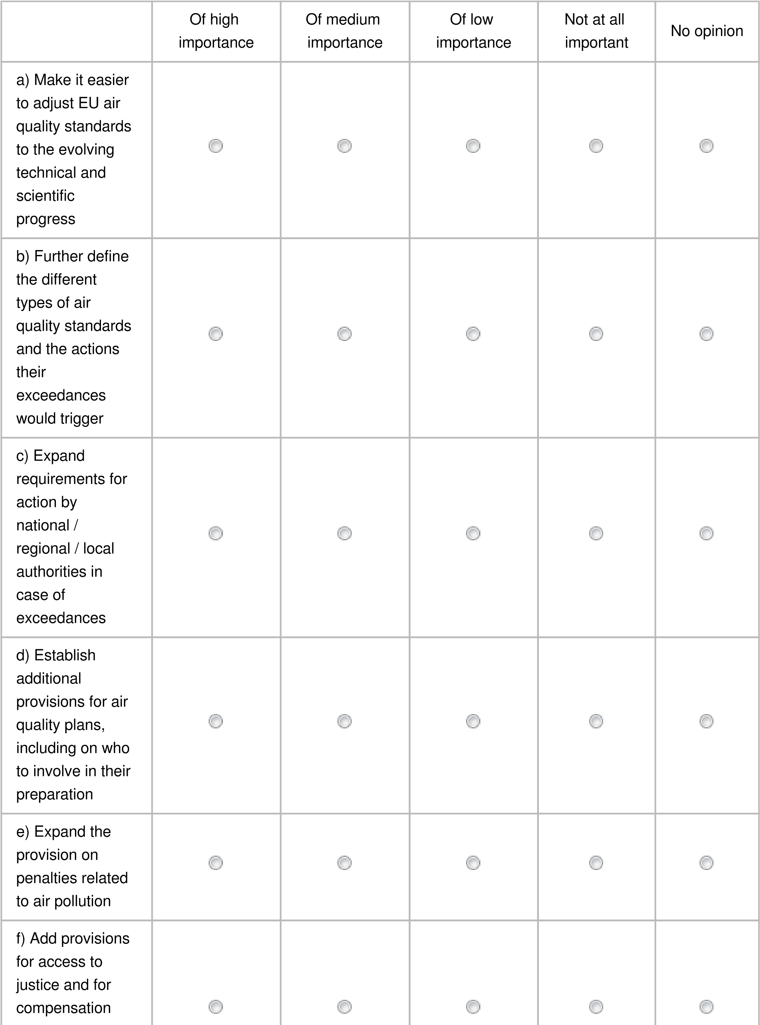



for health

damage from air

pollution

g) Expand the

requirements on

the provision of

information (e.g.

on health

impacts)



Public awareness must increase to improve compliance and promote “secondary” protective measures.

Key to improve/ensure limit value compliance, citizens involvement and air pollution awareness.

The AQD’s effectiveness depend on fast and firm action (incl. penalties) to address non-compliance.

There is need for more coherence in designing the various measures, their prioritization and assignment to involved actors

Encourage the creation of intergovernance bodies and plans to allow for integrated action

Establish a mechanism for automatic adaptation of standards along the best available scientific knowledge.

Please explain your answer, if you wish

100

character(s) maximum

100

character(s) maximum

a) Make it easier to adjust EU air quality standards to the evolving technical and

scientific progress

b) Further define the different types of air quality standards and the actions their

exceedances would trigger

c) Expand requirements for action by national / regional / local authorities in case of

exceedances

d) Establish additional provisions for air quality plans, including on who to involve in

their preparation

e) Expand the provision on penalties related to air pollution

f) Add provisions for access to justice and for compensation for health damage from

air pollution

g) Expand the requirements on the provision of information (e.g. on health impacts)

23. How important are the following options for policy area 3* to improve the effectiveness of the Ambient Air Quality Directives?

* Strengthening of air quality monitoring, modelling and plans.

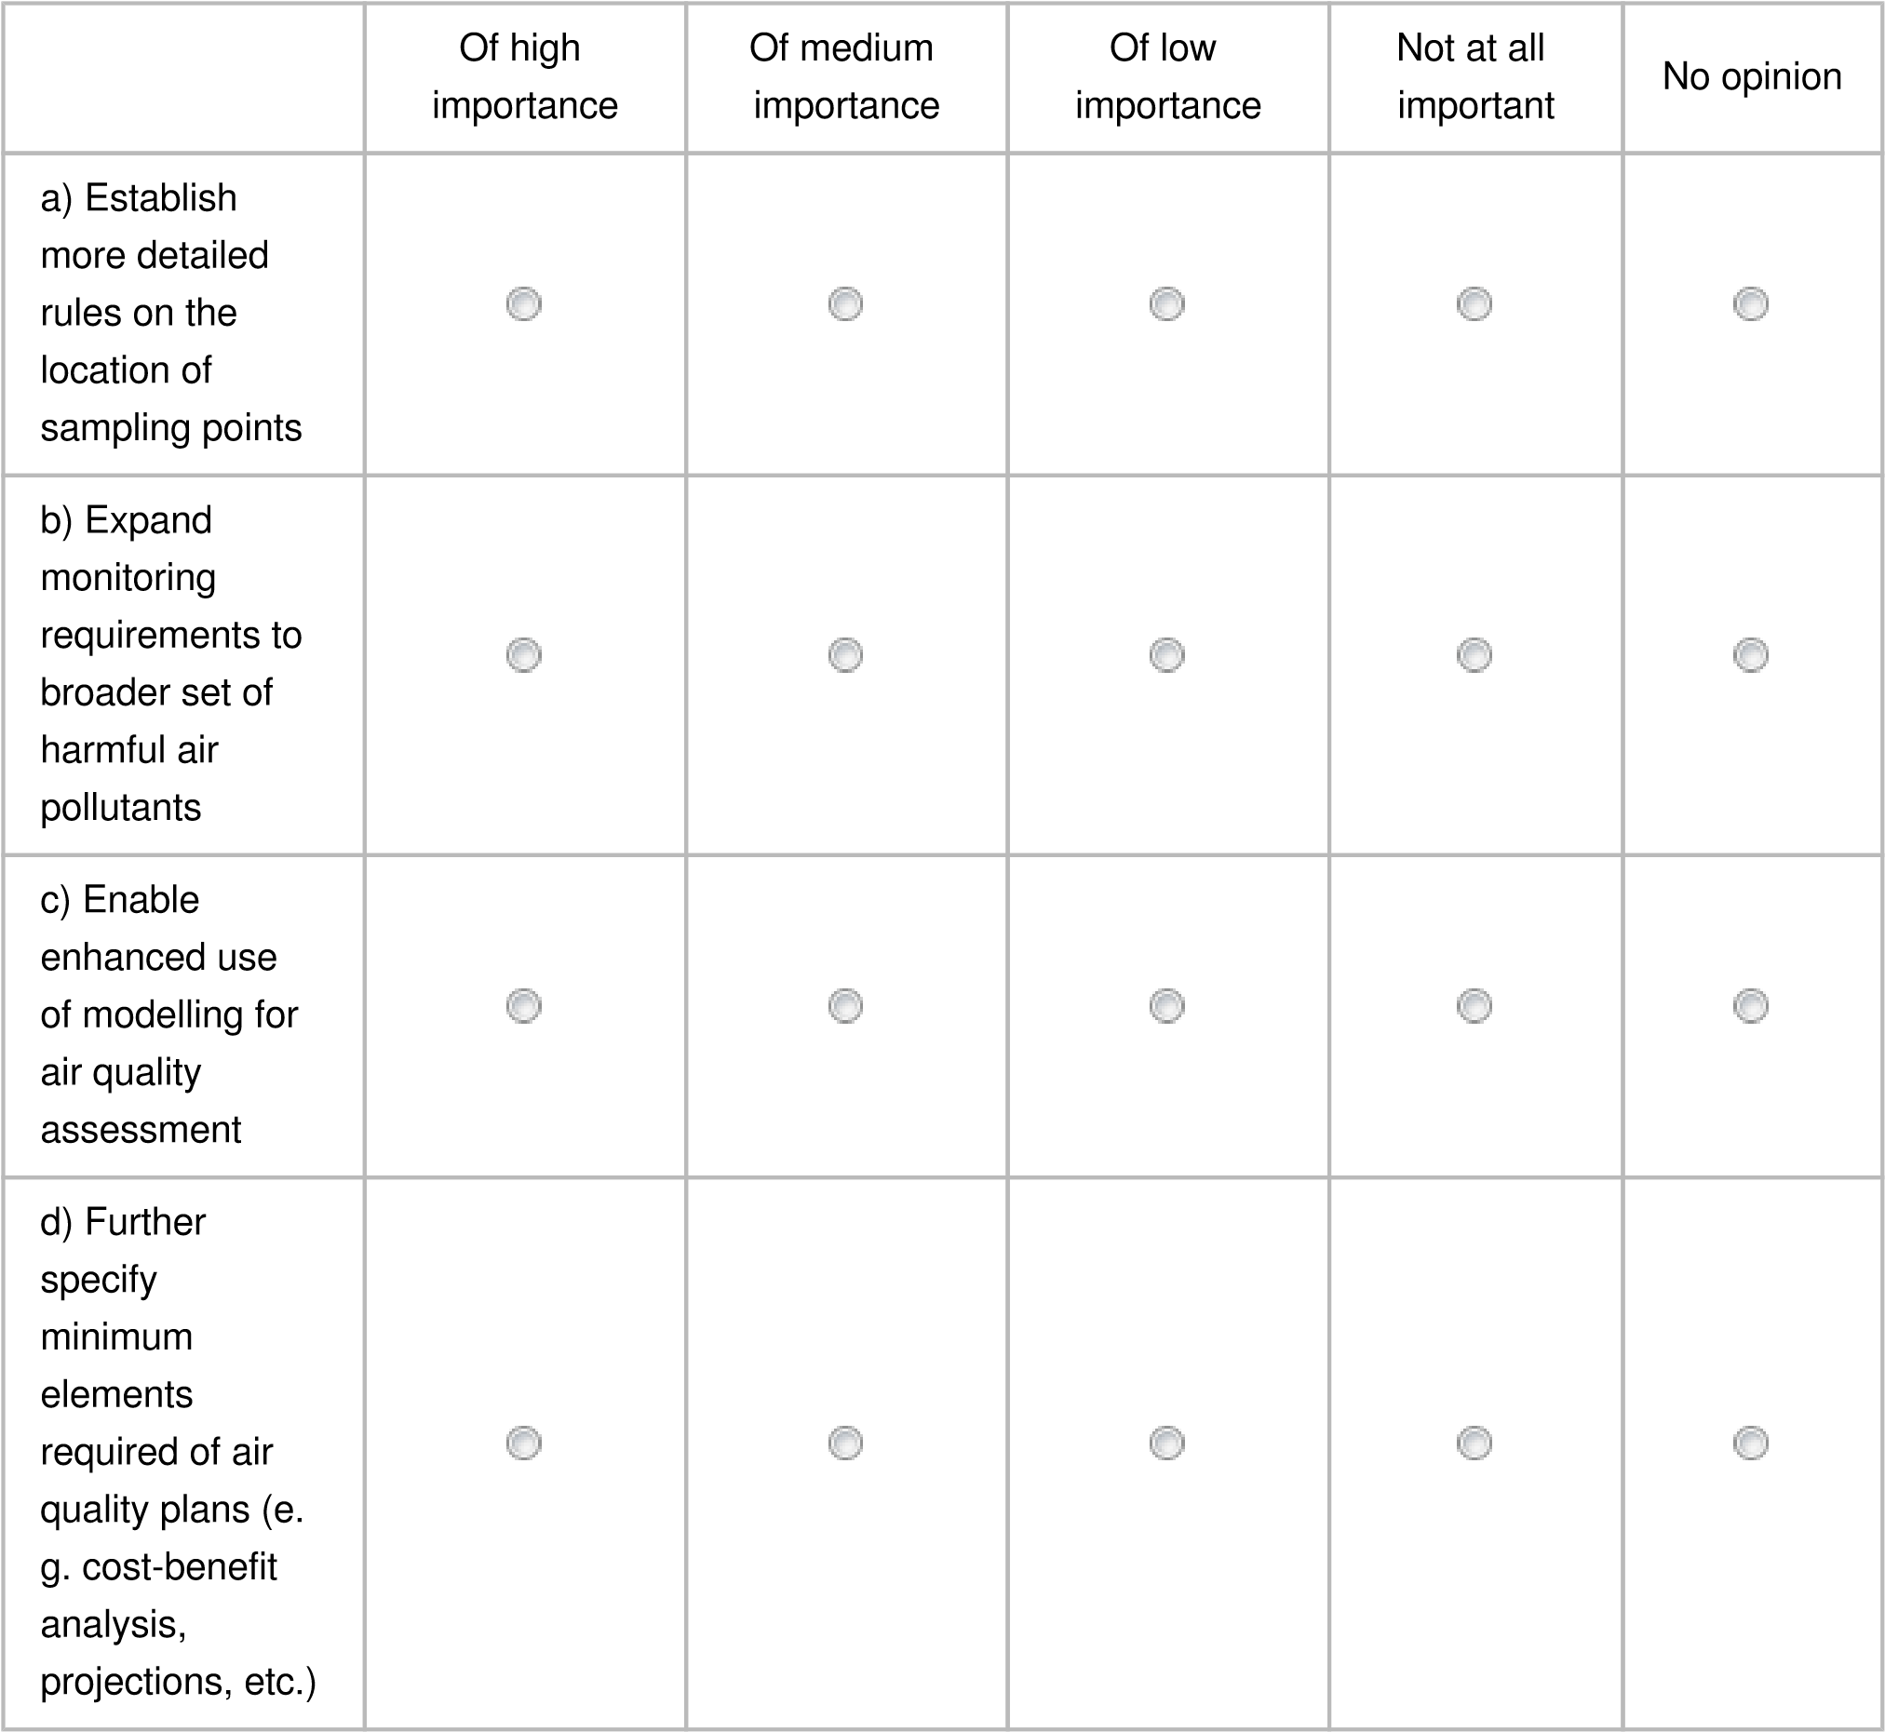



Modelling should be integrated in the assessment of infringements.

 Monitoring of UFP, BC, among others urgently needed (with limit values) in AAQD.

Necessary to protect health of vulnerable groups everywhere

A must to make plans more coherent and effective. See also the EU Urban Air Quality Partnership guidance document on air quality plans<https://bit.ly/3F8FiGk>

Please explain your answer, if you wish

100

character(s) maximum

100

character(s) maximum

a) Establish more detailed rules on the location of sampling points

b) Expand monitoring requirements to broader set of harmful air pollutants

c) Enable enhanced use of modelling for air quality assessment

d) Further specify minimum elements required of air quality plans (e.g. cost-benefit

analysis, projections, etc.)

Other

1. How feasible (i.e. technically, politically, from a cost perspective, etc.) would the following policy measures related to policy area 1* be to implement?

*Closer alignment of the EU air quality standards with scientific knowledge including the latest recommendations of the World Health Organization (WHO).

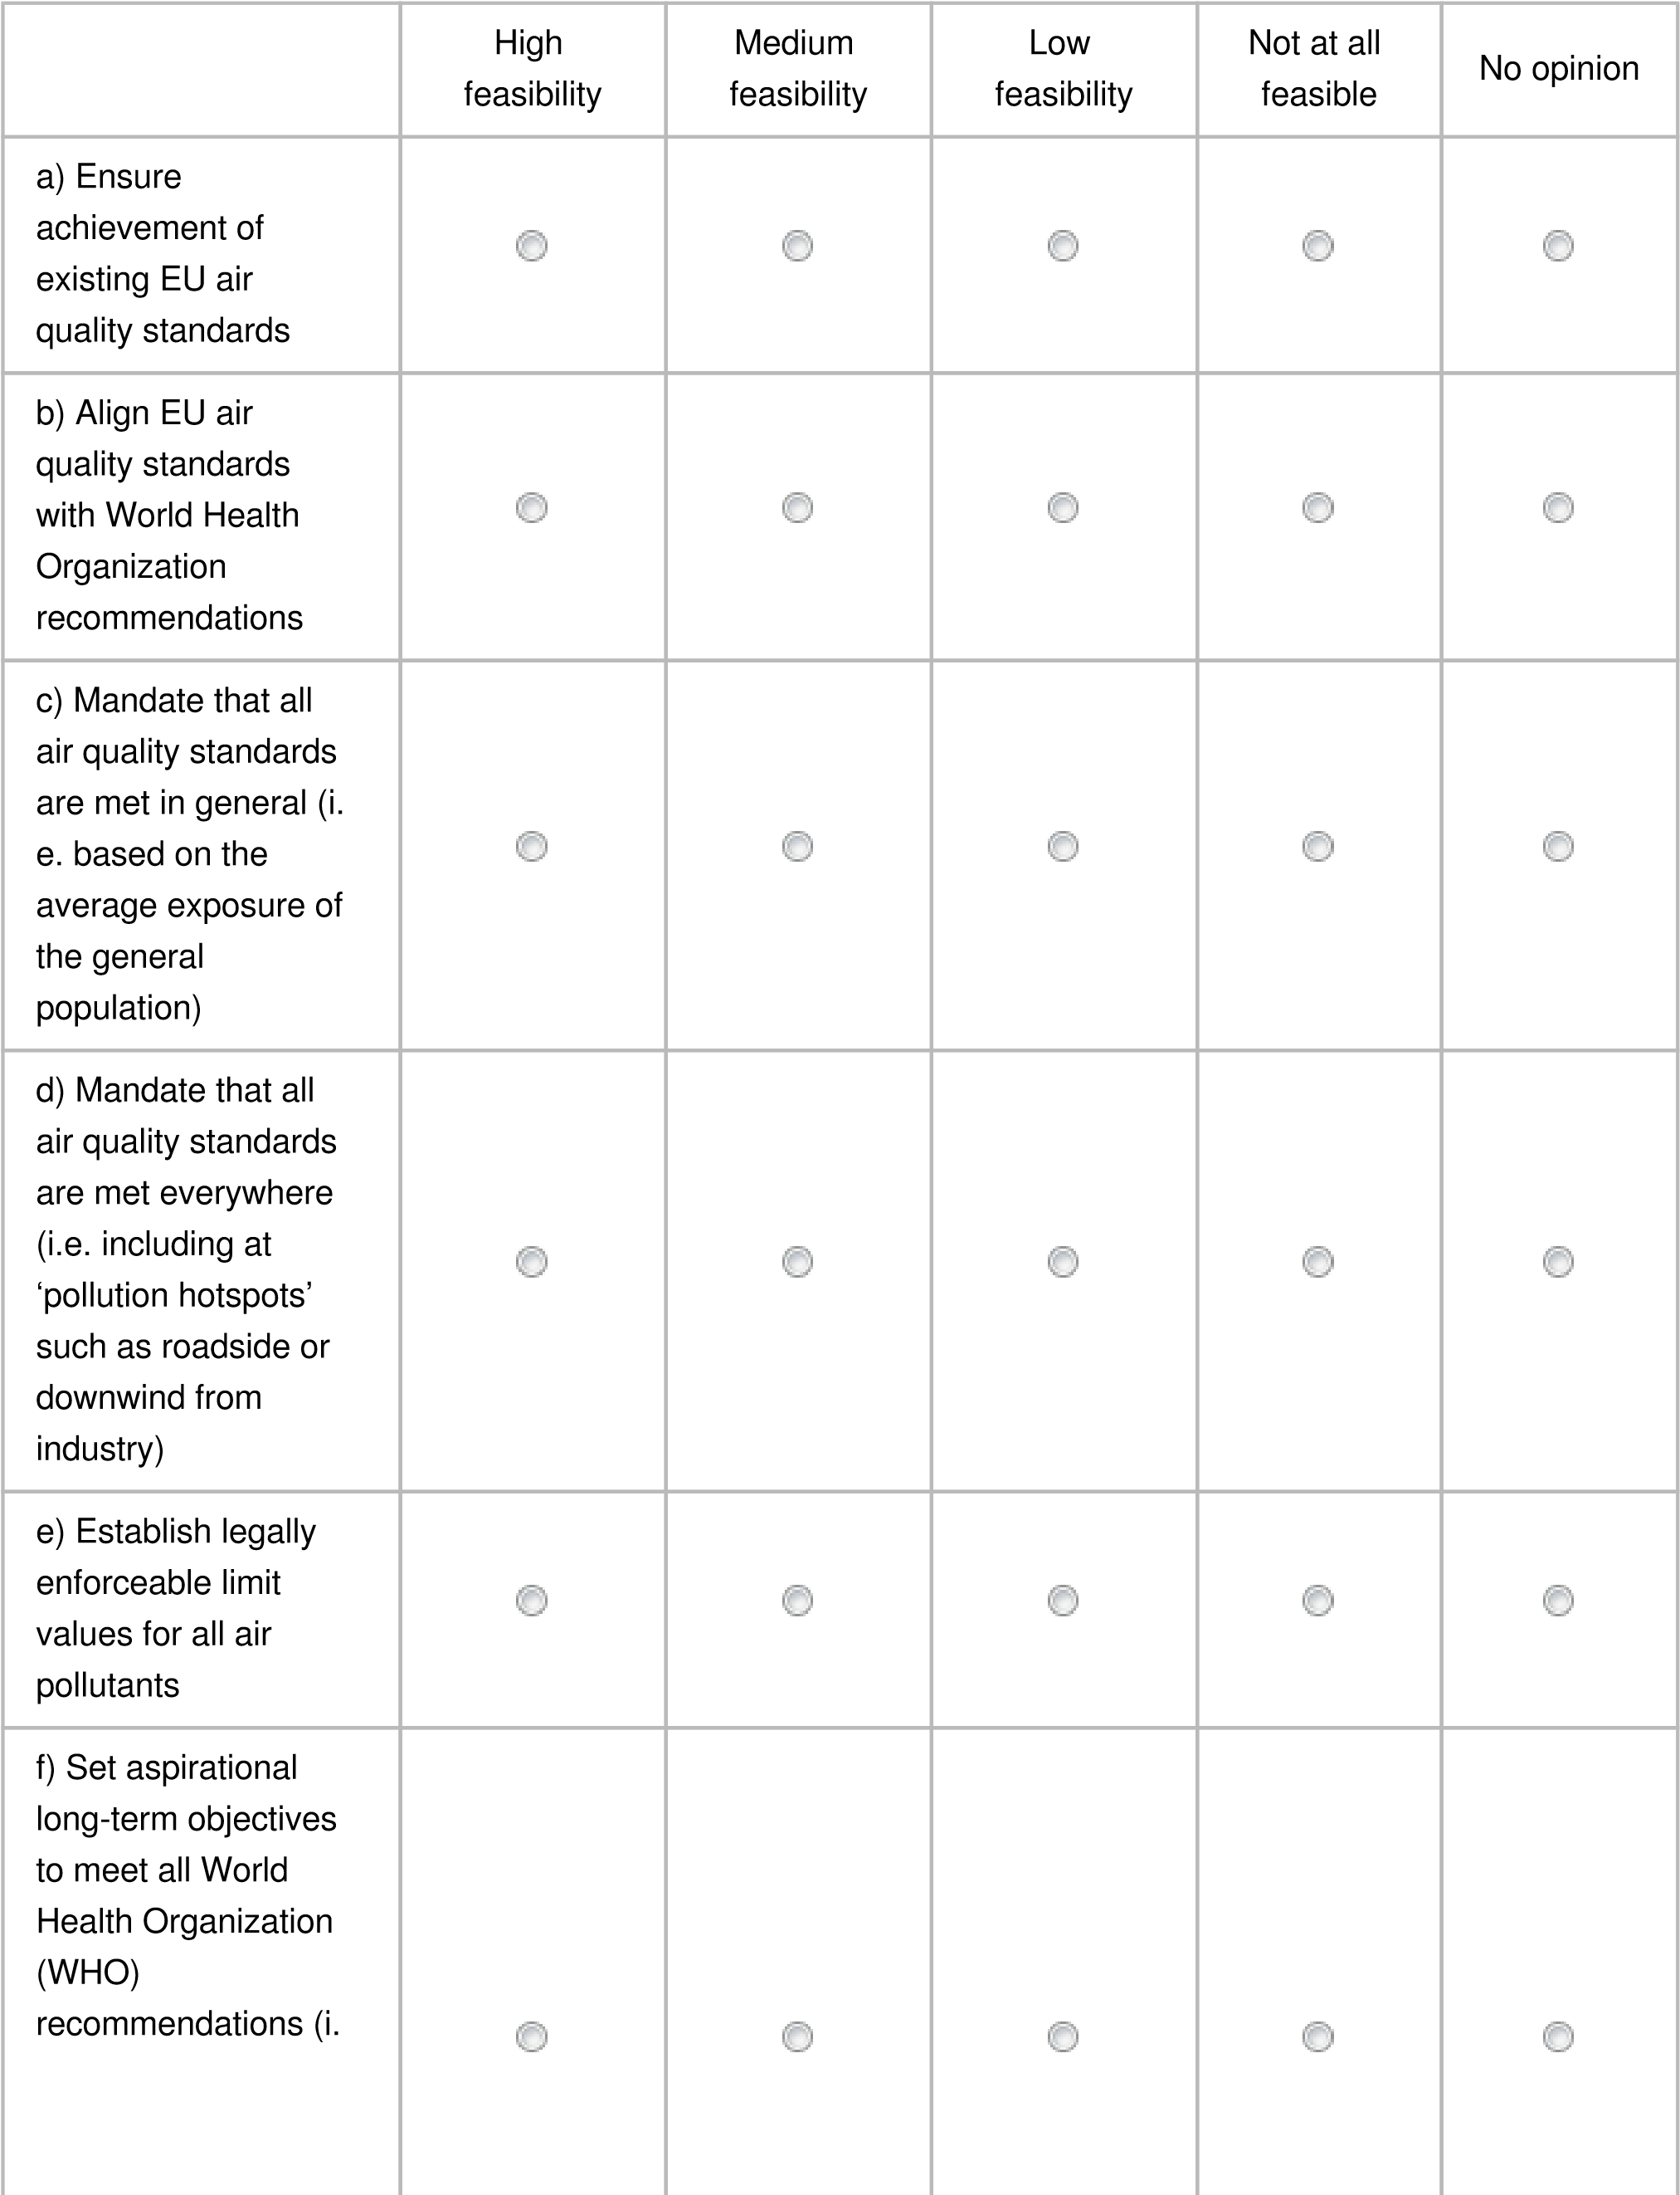



e. as per updated

WHO Air Quality

Guidelines)

WHO AQG must be mandatory EU limit values as soon as possible, i.e. not only aspirational long term.

Conclusion of fitness check report: Binding limits proven to be most effective in reducing air pollution than other standards.

UN Human Rights Council recognised access to a clean and healthy environment as a fundamental right.

Ave. expo. reduction should only be complementary to binding limit values everywhere.

EU standards must follow best available scientific knowledge and advice and AAQD should enable this.

**The socio-economic benefits of air pollution reductions are higher than the implementation costs**.

Please explain your answer, if you wish

100

character(s) maximum

100

character(s) maximum

a) Ensure achievement of existing EU air quality standards

b) Align EU air quality standards with World Health Organization recommendations

c) Mandate that all air quality standards are met in general (i.e. based on the average

exposure of the general population)

d) Mandate that all air quality standards are met everywhere (i.e. including at ‘pollution

hotspots’ such as roadside or downwind from industry)

e) Establish legally enforceable limit values for all air pollutants

f) Set aspirational long-term objectives to meet all World Health Organization (WHO)

recommendations (i.e. as per updated WHO Air Quality Guidelines)

Other

1. How feasible (i.e. technically, politically, from a cost perspective, etc.) would the following policy measures related to policy area 2* be to implement?

* Improving the current air quality legislative framework (including aspects such as penalties and public information).

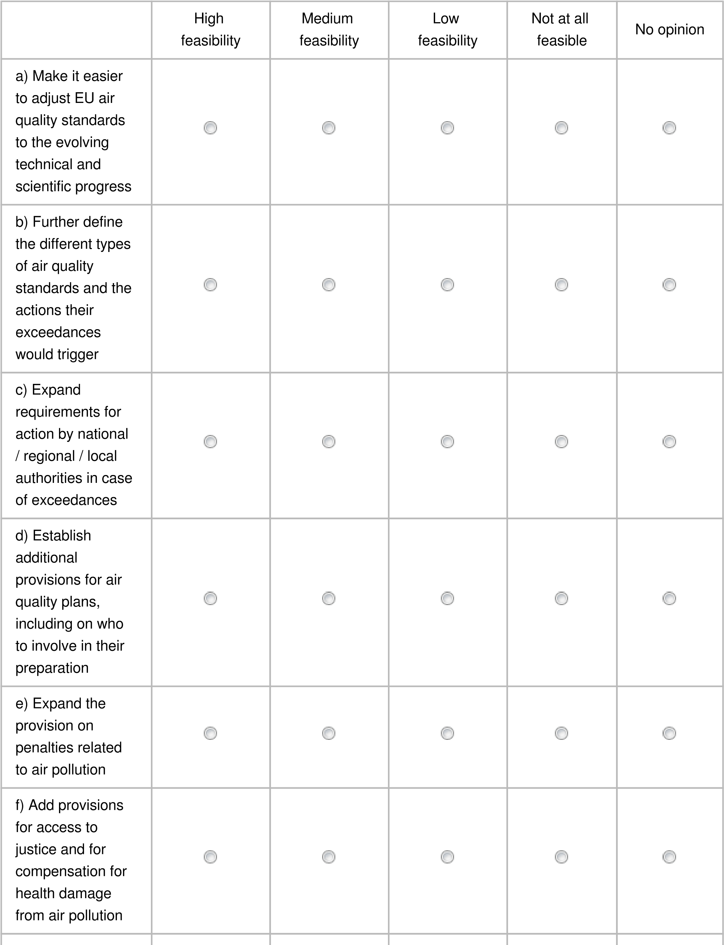



29



g) Expand the

requirements on

the provision of

information (e.g.

on health impacts)



Please explain your answer, if you wish

100

character(s) maximum

100

character(s) maximum

a) Make it easier to adjust EU air quality standards to the evolving technical and

scientific progress

b) Further define the different types of air quality standards and the actions their

exceedances would trigger

c) Expand requirements for action by national / regional / local authorities in case of

exceedances

d) Establish additional provisions for air quality plans, including on who to involve in

their preparation

e) Expand the provision on penalties related to air pollution

f) Add provisions for access to justice and for compensation for health damage from

air pollution

g) Expand the requirements on the provision of information (e.g. on health impacts)

Other

26. How feasible (i.e. technically, politically, from a cost perspective, etc.) would the following policy measures related to policy area 3* be to implement?

* Strengthening of air quality monitoring, modelling and plans.

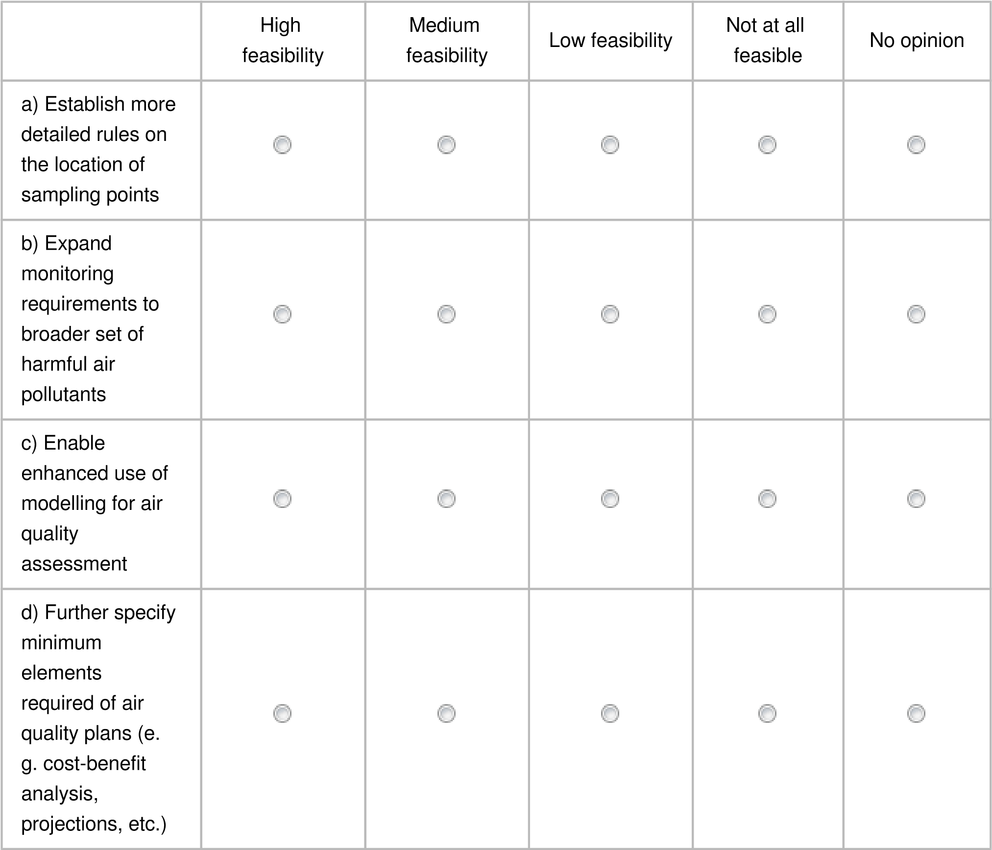



Please explain your answer, if you wish

100

character(s) maximum

100

character(s) maximum

a) Establish more detailed rules on the location of sampling points

b) Expand monitoring requirements to broader set of harmful air pollutants

c) Enable enhanced use of modelling for air quality assessment

d) Further specify minimum elements required of air quality plans (e.g. cost-benefit

analysis, projections, etc.)

Other

27. If you believe that some measures listed above are incoherent with EU strategies (e.g. the European Green Deal), incoherent with EU sectoral policies (e.g. on transport, energy or agriculture), or incoherent with national level policies, could you please briefly elaborate on your answer?

600 character(s) maximum

Some existing policy measures outside on the AAQD are currently incoherent with EU’s and Member States ability to protect health from air pollution. These include: continued use and subsidizing of fossil fuel burning, lagging behind in regulating car and other transport emissions, lack of measures to massively and urgently shift to public transportation and active mobility in every urban environment.

# Part 4: Concluding questions & remarks

1. What is your level of knowledge of the following? No BRAL guidance

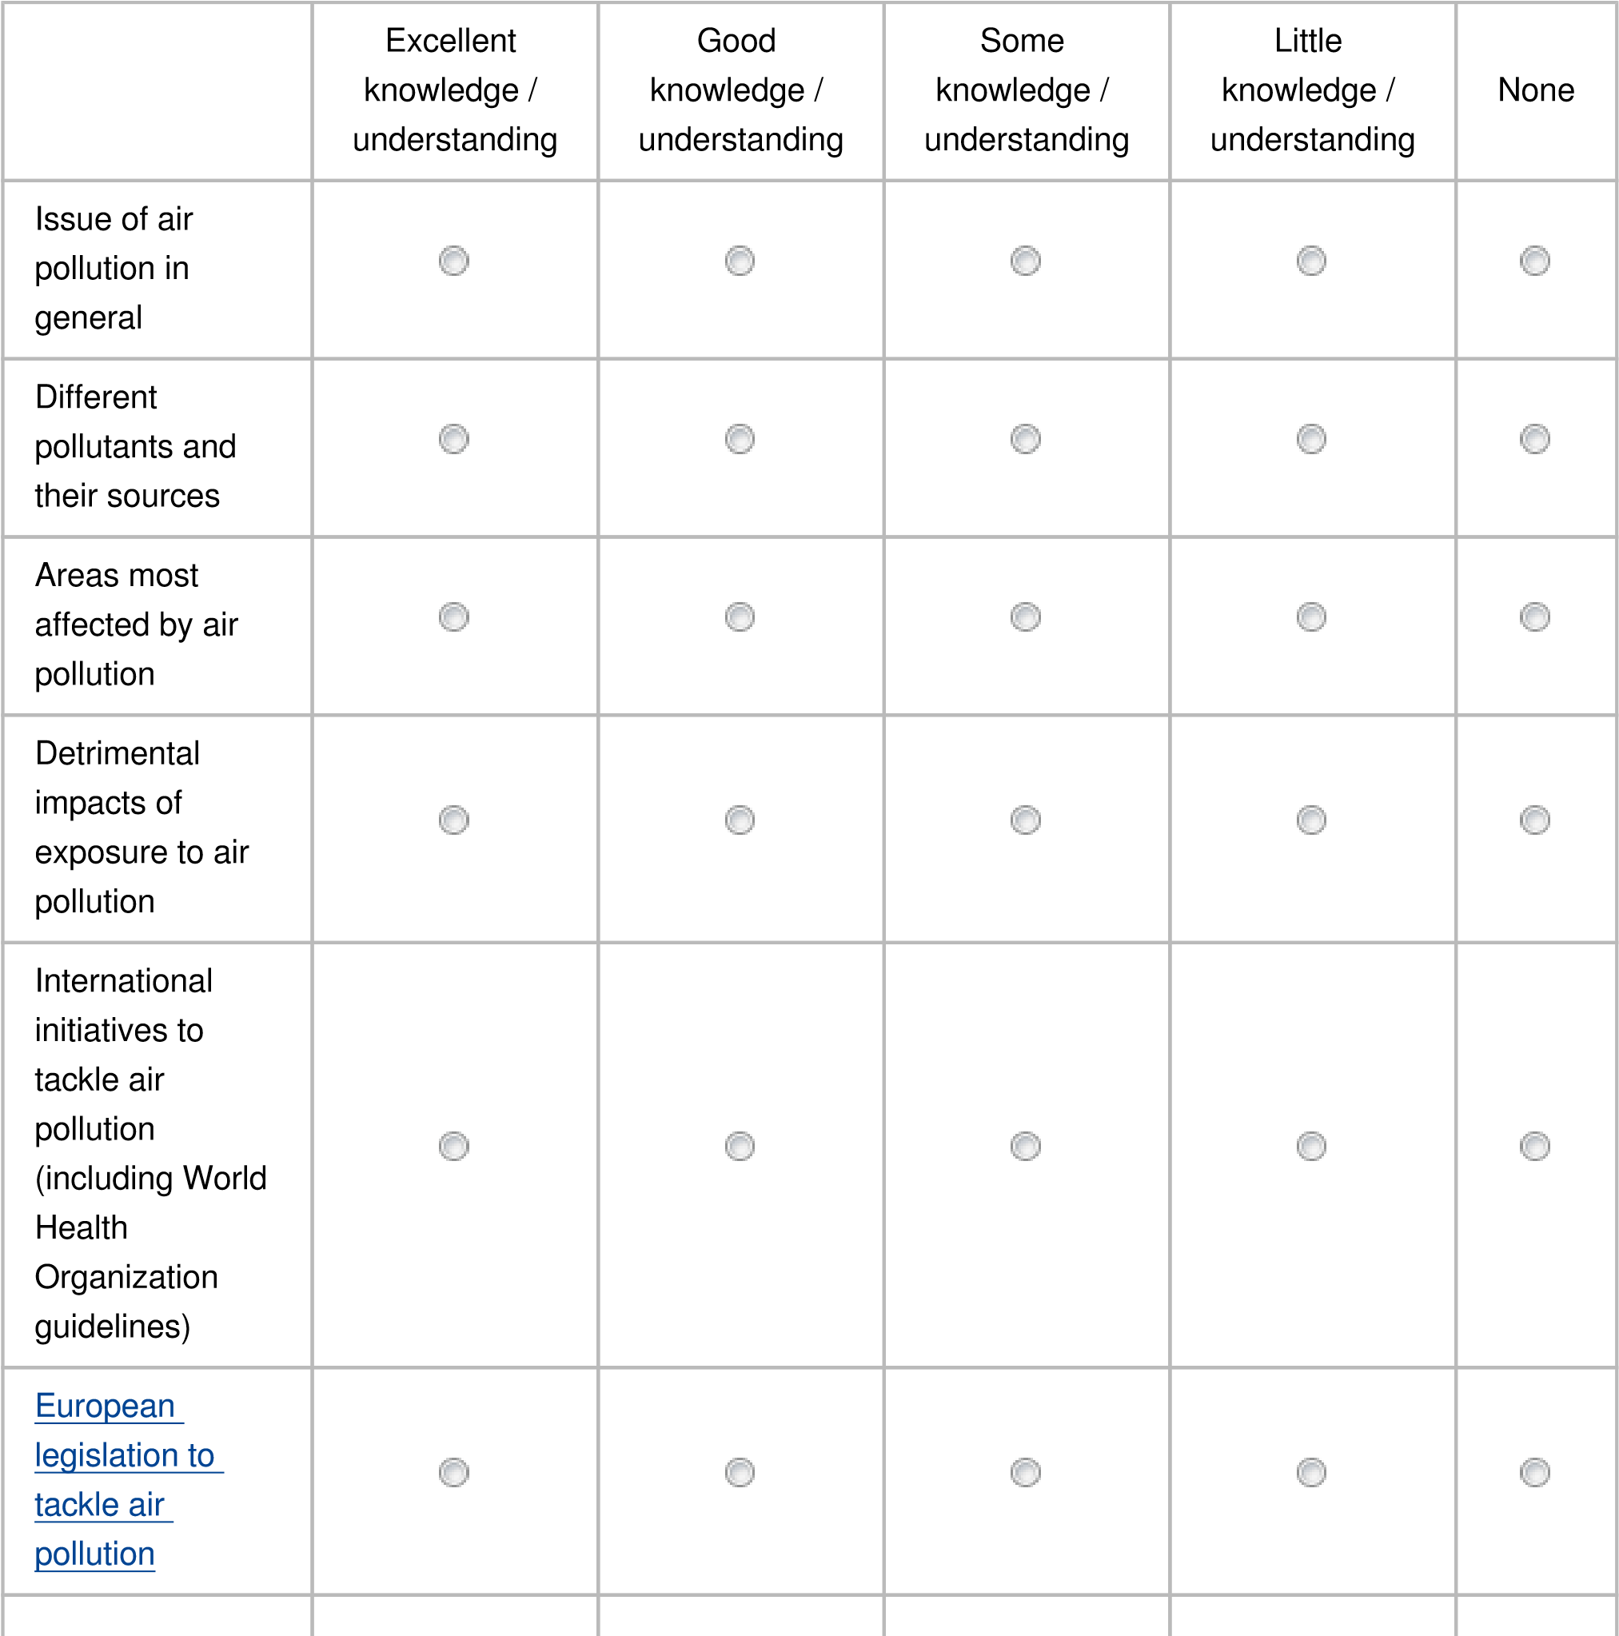

Implementation

of European

legislation to

tackle air

pollution



36

1. If you wish to expand on any of your answers or if you wish to add comments or information on anything else, which is relevant to the Impact Assessment, please do so in the box below.

800 character(s) maximum

The main question is not “what is currently feasible” to reach WHO’s recommendations but “how to make it happen as soon as possible & by 2030 at the latest”. A higher vulnerability of socially deprived people or the fact that living close to busy roads increases children’s asthma risk has so far not been addressed: a more comprehensive policy framework is needed. The EU must lead a global urgent cutting of air pollution. Air pollution & climate change largely originate from same sources: combustion of fossil fuels. Stricter air quality standards fuel needed climate action, win-win measures should be prioritised. Therefore, the baseline scenario should include full implementation of the whole EU acquis that will contribute to lower emissions of air pollutants, NECD as well as sector policies, such as for energy (incl. domestic heating), transport (incl. Euro 7/VII standards) and agriculture.

30. If you consider there are materials / publications available online that should be considered further in relation to this Impact Assessment exercise, please feel free to describe them (title and author) in the box below and include any relevant links

800 character(s) maximum

*ELAPSE study on long term to low levels 2021 <https://www.bmj.com/content/374/bmj.n1904>

*IS Global study on cities 2021 <https://www.thelancet.com/journals/lanplh/article/PIIS2542-5196(20)30272-2/fulltext>

*WHO 2019 assessment report on environmental health inequalities <https://www.euro.who.int/__data/assets/pdf_file/0010/157969/e96194.pdf>

\***Nieuwenhuijsen MJ.**  Urban and transport planning pathways to carbon neutral, livable and healthy cities; A review of the current evidence <https://www.sciencedirect.com/science/article/pii/S0160412020302038>

31. Do you have additional information that you would like to share in a concise document such as a position paper? (This is optional and will serve as additional background to better understand your position.) NO paper by BRAL, but feel free to include HEAL’s and/or EEB’s positions papers.

The maximum file size is 1MB

Only files of the type pdf,txt,doc,docx,odt,rtf are allowed

HEAL position paper <https://www.env-health.org/wp-content/uploads/2021/09/HEAL_10-demands_-air-quality_September21.pdf>

EEB Position paper

37